Chapter 15, Problem 34.

Find the time functions that have the following Laplace transforms:

(a) 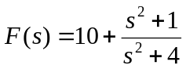
(b) 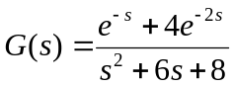
(c) 